# NETWORKING & SYSTEM ADMINISTRATION LAB

**Name: MELBIN M P**

**Roll No: 17**

**Batch: s2 RMCA B Date: 09-05-22**

**Experiment No : 13**

1. Write a shell script to display current date and Calender.

# Procedure:

#!/bin/bash

echo " Current date is $(date)" echo " Calender :"

cal

# Output:

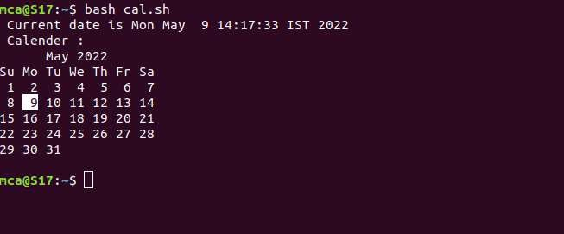

1. Write a shell script to check a number is greater than,less than or equal to another number.

# Procedure:

#!/bin/bash

echo "Enter the first number:" read n1

echo "Enter the second number:" read n2

if [ $n1 -gt $n2 ] then

echo "The first number is greater than second number" elif [ $n2 -gt $n1 ]

then

echo "The first number is less than second number" else

echo "The first number is equal to second number" fi

# Output:

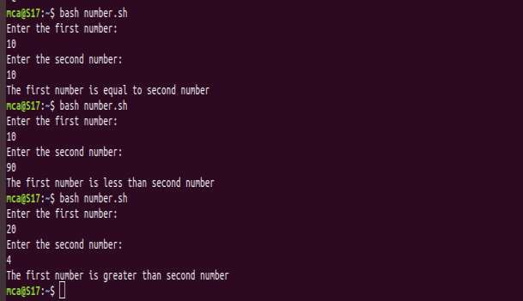

1. Write a shell script to find sum of first 10 numbers.

# Procedures:

#!/bin/bash

echo "The sum of the first 10 numbers are:" sum=0

for (( i=1;i<=10;i++)) do

sum=$((sum+i)) done

echo $sum

# Output:



1. Write a shell script to find sum,average and product of 4 numbers.

# Procedures:

#!/bin/bash

echo "Enter the number1:" read n1

echo "Enter the number2:" read n2

echo "Enter the number3:" read n3

echo "Enter the number4:" read n4

sum=0 sum=$((n1+n2+n3+n4)) avg=0

avg=$((sum/4)) pro=0

pro=$((n1 * n2 * n3 * n4))

echo "The sum of the numbers are:" $sum echo "The average of the numbers are:"$avg echo "the product of the numbers are:"$pro

# Output:

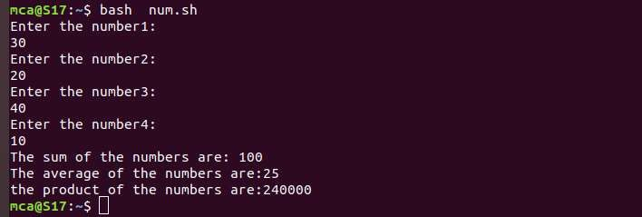

1. Write shell script to find factorial of a given number.

# Procedures:

#!/bin/bash

echo "Enter the number:" read num

fact=1

for(( i=2;i<=num;i++ )) do

fact=$((fact*i)) done

echo "The factorial is "$fact

# Output:



1. Write shell script to find the given number is palindrome or not.

# Procedure:

#!/bin/bash

echo "Enter the number:" read num

s=0 rev=" "

temp=$num

while [ $num -gt 0 ] do s=$(($num%10)) num=$((num/10))

rev=$(echo ${rev}${s}) done

if [ $temp -eq $rev ] then

echo "The number is palindrome" else

echo "The number is not palindrome" fi

# Output:

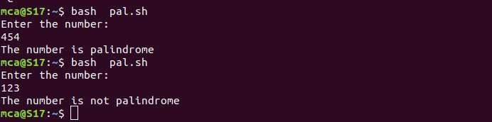

1. Write a shell script to find given year leap year or not.

# Procedure:

#!/bin/bash

echo "Enter the year:" read year

if [ $((year % 4)) -eq 0 ] then

if [ $((year % 100)) -eq 0 ] then

if [ $((year % 400)) -eq 0 ] then

echo "its a leap year" else

echo "its not a leap year"

fi else

echo "Its not a leap year" fi

else

echo "its not a leap year"

fi

# Output:

